December 2019

Holiday Book Exchange

Our class will be having a book exchange on Wednesday, December 18th. I am asking each student to bring in one new or gently used book to participate in the exchange. Each student that brings in a book will get a book from another student to keep at home! During our exchange, we will be discussing the importance of giving, and using our manners. Please send the book in unwrapped on or before Friday, December 13th. This will give us time to arrange the exchange and have students wrap and write a note to the student they are giving their book to.
Please let me know if you have any questions!
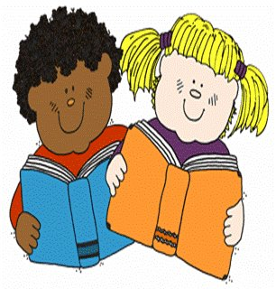 First Grade

